|  |  |  |  |
| --- | --- | --- | --- |
| **Nama** | Edgrant Henderson Suryajaya | **Kode Asisten** | ………………………… |
| **NPM** | 2206025016 | **Jenis Tugas** | TP/CS…………………. |

**Jawaban**

1. .

library ieee;

use ieee.std_logic_1164.all;

entity adder_3 is

    port(

        -- Input

        a : IN STD_LOGIC; --MSB

        b : IN STD_LOGIC;

        c : IN STD_LOGIC;

        d : IN STD_LOGIC; --LSB

        --output

        out_a : OUT STD_LOGIC;

        out_b : OUT STD_LOGIC;

        out_c : OUT STD_LOGIC;

        out_d : OUT STD_LOGIC

    );

end entity;

architecture adder_3_archi of *adder_3* is

begin

    out_a <= a OR (b AND c) OR (b AND d);

    out_b <= (NOT b AND c) OR (NOT b AND d) OR (b AND NOT c AND NOT d);

    out_c <= (b AND NOT d) OR (c AND d) OR (NOT a AND NOT c AND NOT d);

    out_d <= (c AND NOT d) OR (NOT c AND NOT d);

end architecture;

1. .
2. 0101

1. 1100

1. 0011

1. 1010

1. .

Keduanya sama intinya, tetapi pada sintesis RTL tidak menggunakan NOT, tetapi langsung NOT-nya di AND gatenya.

1. .

library ieee;

use ieee.std_logic_1164.all;

use  IEEE.STD_LOGIC_ARITH.ALL;

entity CS_unsigned is

    port(

        -- Input

        input : IN STD_LOGIC_VECTOR (3 DOWNTO 0); --ini 4 bit, karena bit pertama dipake utk sign

        --output

        output : OUT STD_LOGIC_VECTOR (3 DOWNTO 0) --sama kayak input

    );

end entity;

architecture adder_3_archi of *CS_unsigned* is

    signal in_num : SIGNED (3 DOWNTO 0);

    signal out_num: SIGNED (3 DOWNTO 0);

begin

    in_num <= signed(input);

    out_num <= in_num + 3;

    output <= std_logic_vector(out_num);

end architecture;

1. .
2. -5 (1 1011)

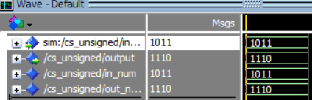 Hasil 1110 (-2)

1. 5 ( 0101)

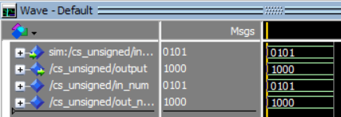 Hasil 1000 (8)

1. -2 (1110)

Hasil 0001 (1)

1. 3 (0011)

Hasil 0110 (6)

1. .

* VHDL digunakan untuk buat rangkaian dengan kode
* STD_LOGIC digunakan untuk menyimpan 1 bit data
* STD_LOGIC_VECTOR digunakan untuk menyimpan banyak bit data
* SIGN dan UNSIGN digunakan utk aritmatika, STD_LOGIC_VECTOR gak bisa aritmatika
* MODELSIM digunakan utk simulasi kode
* QUARTUS digunakan untuk melihat rangkaian yg dibuat